RESOLUTION NO. 2020-XX
A RESOLUTION OF THE CITY COUNCIL OF THE CITY OF MORENO VALLEY, CALIFORNIA, ORDERING THE SUMMARY VACATION OF THE SOUTHERLY PORTION OF FILAREE AVENUE LOCATED FROM 610 FEET WEST OF THE INTERSECTION OF OLIVER STREET TO 1,270 FEET WEST OF OLIVER STREET

WHEREAS, the City Council of the City of Moreno Valley, California, acquired a perpetual easement and right-of-way for public street purposes, including public utility and public service facilities, located west of Oliver Street described as a southerly 40 feet wide portion northerly of lot 2 in the Bear Valley and Alessandro Development Co. as shown by Map Book 11, page 10 of Official Records in the County of San Bernardino; and

WHEREAS, no public improvements exist on said portion of right of way and has not been used for street purposes;

WHEREAS, the City has determined that the subject street right of way is excess; and

WHEREAS, no public money was expended for maintenance of the subject street right of way.

NOW, THEREFORE, THE CITY COUNCIL OF THE CITY OF MORENO
VALLEY, CALIFORNIA, DOES HEREBY RESOLVE AS FOLLOWS:

Section 1

That pursuant to the provisions of Chapter 4, Part 3, of Division 9 of the Streets and Highways Code of the State of California, designated the “Public Streets, Highways and Service Easements Vacation Law,” the following described portion of right-of-way is summarily vacated and abandoned:
That said portion of Filaree Avenue as described and illustrated on the plat, attached hereto and made a part hereof, marked as Exhibits “A” and “B”. This summary vacation is made based upon the facts presented.

Section 2
That pursuant to the provisions of Sections 831 of Title 3 and 1112 of Title 4, Part
2, Division 2 of the California Civil Code of the State of California, title to the above-described portion of land reverts to the owners of the underlying fee thereof, free from use as an easement for public highway purposes.

Section 3
That from and after the date the resolution is recorded, the easement vacated no longer constitutes a street or public service easement.

Section 4

That the City Clerk of the City of Moreno Valley, California, shall cause a certified copy of this Resolution to be recorded in the office of the Recorder for the County of Riverside, California.

APPROVED AND ADOPTED this 17th day of November, 2020.

___________________________
Mayor of the City of Moreno Valley
ATTEST:

____________________________
City Clerk

APPROVED AS TO FORM:

____________________________
City Attorney

RESOLUTION JURAT

STATE OF CALIFORNIA )
COUNTY OF RIVERSIDE ) ss.
CITY OF MORENO VALLEY )
I, Pat Jacquez-Nares, City Clerk of the City of Moreno Valley, California, do hereby certify that Resolution No. 2020-XX was duly and regularly adopted by the City Council of the City of Moreno Valley at a regular meeting thereof held on the 17th day of November, 2020 by the following vote:

AYES:

NOES:

ABSENT:

ABSTAIN:

(Council Members, Mayor Pro Tem and Mayor)

___________________________________
CITY CLERK

(SEAL)

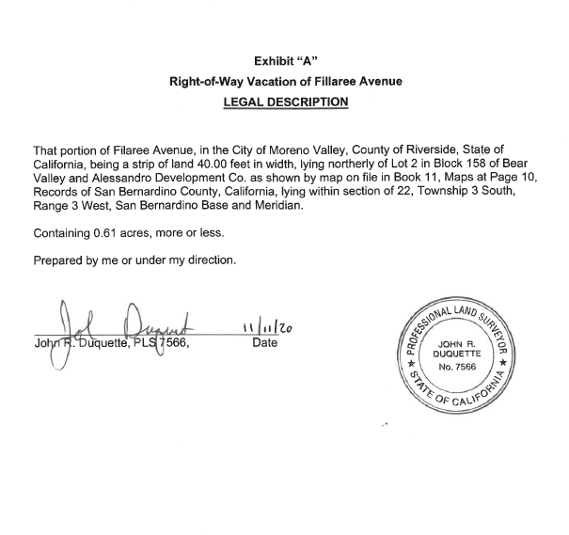

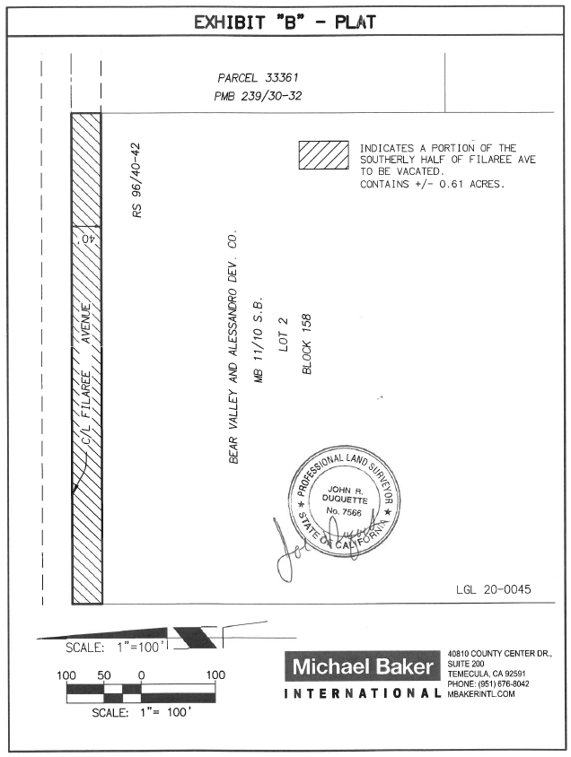
EXHIBIT “B”

